

19TH ANNUAL HARD SHELL OPEN
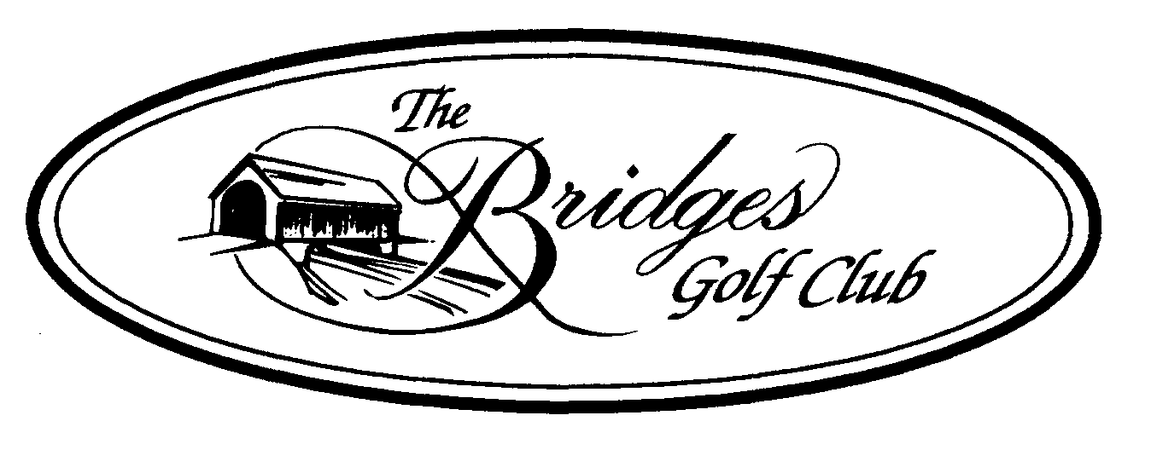
When: Friday, September 1st – 12:00pm Shotgun Start
Format: 4 Person Scramble
Tees: Ladies – Red / Age 65+ - Gold / All Others – White
Entry Fees: $440.00 per team includes:
*Round of Golf W/Cart
*Refreshments following play – Beer, Soda, & Water
*Commemorative Logo Item
*Hard Shell Crabs – All you can eat
*Subway subs & Chips
*Raffle & Door Prizes
*Optional cash skins game $20/team
*Optional Mulligan & Power drive package (1 each per player) $20/team
*Prize money to be determined by # of players (2022 - $2,880)
3 Flights Paying 1st & 2nd
Closest to the pin prizes on all Par 3’s – Men’s & Ladies Long Drive

Name ____________________________ Email ____________________________

Name ____________________________ Email ____________________________

Name ____________________________ Email ____________________________

Name ____________________________ Email ____________________________

Full payment (CASH OR CHECK) & completed entry form required to reserve spot

The Bridges Golf Club ~ 6729 York Road, Abbottstown PA 17301 ~ (717) 624-9551

Sorry no refunds after – August 29th



