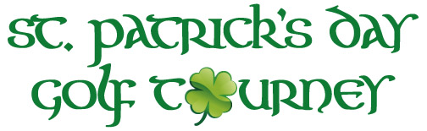
DATE: Saturday March 16th &/Or Sunday March 17th, 2024
TIME: 10:00am Shotgun Start
FORMAT: 4 Person Scramble
ENTRY: $300.00/Team
INCLUDES: Greens/Cart/Range Fees; Door/Skill/Place Prizes, Lunch & Beverages after Play
$20 From Each Player Will Be Put Towards Prizes!
Players wearing green will receive an extra door prize ticket!!!
Door/Skill/Place prizes will be awarded on both days.
Entries/Refunds Deadline: March 14th ~ Credit Card payments accepted after March 1st
_____________________________________________________________________________
Captain:_______________________________________
Phone:________________________________________
Email:________________________________________
Address: ______________________________________
Player 2: ________________________________
Player 3: ________________________________
Player 4: ________________________________
The Bridges Golf Club ~ 6729 York Road ~ Abbottstown, PA ~ Attn: St. Patty’s Day

