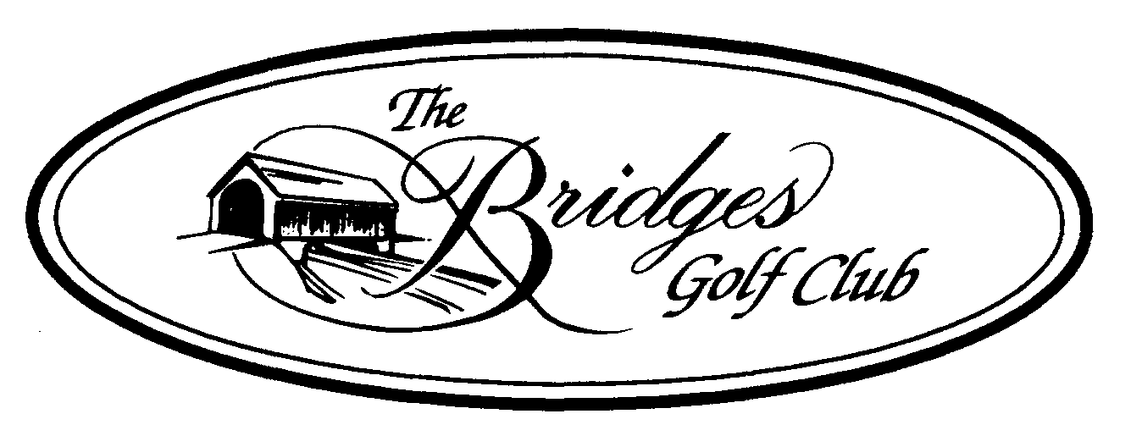

21ST ANNUAL HARD-SHELL OPEN

When: Friday, August 29th – 12:00pm Shotgun Start
Format: 4 Person Scramble
Tees: Ladies – Red / Age 65+ - Gold / All Others – White
Entry Fees: $480.00 per team including:
*Greens/Cart/Range fees
*Keg & water at Clubhouse during play, Keg, Soda, Water following
*Commemorative logo gift
*Crabs – All you can eat
*Subway subs, chips, & cookies
*Raffle & Door prizes
*Optional cash skins game $20/team
*Optional Mulligan/Power drive package (1 each per player) $20/team
*3 Flights paying 1st & 2nd
*Closest to pin prizes on all Par 3’s ~ Men’s & Ladies Long Drive
*Total Prize Money (2024 - $3,042)

Captain’s Name ______________________ Email ______________________________

Adress _________________________________________________________________

Phone ____________________________ Player 2 ____________________________

Player 3 ____________________________ Player 4 ____________________________

Full payment $480 (CASH OR CHECK) & completed entry form to reserve your spot.

The Bridges Golf Club ~ 6729 York Road, Abbottstown PA 17301 ~ (717) 624-9551

Sorry, no refunds after – August 26^{th.}




