BURGER NIGHT EVERY TUESDAY 4PM-9PM!!!
SERVED WITH CHIPS OR COLESLAW
ADD FF $1.75 ONION RINGS $2.50 MAC AND CHEESE $2.75 TATER TOTS $2.50

Hamburger $7.50
Fresh half pound certified fresh Angus burger on a toasted roll with lettuce, tomato, and onion. Add cheese for .50

Black and Bleu Burger $8.95
Fresh half pound certified fresh Angus burger on a toasted roll topped with Cajun seasoning, bleu cheese crumbles, lettuce, tomato, and onion.

Pizza Burger $8.95
Fresh half pound certified fresh Angus burger on a toasted roll cooked to your liking topped with marinara, melted American, lettuce, tomato and onion.

Mushroom Swiss Burger $8.95
Fresh half pound certified fresh Angus burger on a toasted roll cooked to your liking topped with sautéed mushrooms, melted swiss cheese, lettuce, tomato, and onion.

South of the Border Burger $8.95
Fresh half pound certified fresh Angus burger on a toasted roll cooked to your liking topped with salsa, jalapenos, shredded cheddar jack cheese, lettuce, tomato, and onion.

Smokehouse Burger $8.95
Fresh half pound certified fresh Angus burger cooked to your liking on a toasted roll with grilled ham, bbq sauce, melted swiss, lettuce, tomato, and onion.

Italian Burger Melt $8.95
Fresh half pound certified fresh Angus burger cooked to your liking on grilled texas toast with melted mozzarella, marinara.

Cheeseburger Wrap $8.95
Fresh half pound certified fresh Angus burger cooked to your liking in a warm tortilla with American cheese, lettuce, tomato, onion, pickle chips, and mayo. Add Bacon $1.00

Buffalo and Bleu Burger $8.95
Fresh half pound certified fresh Angus burger on a toasted roll topped with Cajun seasoning, hot sauce, bleu cheese crumbles, lettuce, tomato, and onion.

Philly Cheese Burger $9.95
Fresh half pound certified fresh Angus burger cooked to your liking on a toasted roll with creamy nacho cheese sauce, sautéed green peppers, sautéed mushrooms, and sautéed onions.

Texas Burger 9.95
Fresh half pound certified fresh Angus burger cooked to your liking on a toasted roll smothered in BBQ sauce, cheddar jack cheese, and onion rings. With lettuce, tomato, and onion

Patty Melt $9.95
Fresh half pound certified fresh Angus burger cooked to your liking on grilled rye with melted swiss cheese and sautéed onions. Add Bacon for $1.

Pepper Jack Bacon Burger $9.95
Fresh half pound certified fresh Angus burger cooked to your liking served on a toasted roll smothered in melted pepper jack cheese, mayo, bacon. With lettuce, tomato, and onion

A1 Steak Burger $9.95
Fresh half pound certified fresh Angus burger cooked to your liking on a toasted roll with sautéed onions, sautéed mushrooms, melted swiss cheese, and A1 sauce.

Cheeseburger Club $9.95
Fresh half pound certified fresh Angus burger cooked to your liking on toasted Texas Toast with American cheese, and mayo.

Chipotle Bacon Burger $9.95
Fresh half pound certified fresh Angus burger cooked to your liking on a toasted roll with bacon, melted cheddar jack cheese, and chipotle mayo. With lettuce, tomato, and onion

Ghost Burger $9.95
Fresh half pound certified fresh Angus burger cooked to your liking on a toasted roll topped with jalapenos, bang bang sauce, melted pepper jack. With lettuce, tomato, and onion

Bacon Cheeseburger Sub $8.95
Fresh half pound certified fresh Angus burger cooked to your liking on a toasted sub roll with American Cheese, bacon, lettuce, tomato, onion, pickle chips.

Farmer Burger $9.95
Fresh half pound certified fresh Angus burger cooked to your liking on a toasted roll with American cheese, fried egg, bacon. With lettuce, tomato, and onion

Thousand Island Bacon Cheeseburger Sub $9.95
Fresh half pound certified fresh Angus burger cooked to your liking on a toasted sub roll with American Cheese, bacon, lettuce, tomato, onion, pickles, and thousand island dressing.

Crabby Burger $14.50
Fresh half pound certified fresh Angus burger cooked to your liking on a toasted roll topped with a 4oz no filler crab cake with jack and cheddar cheese. With lettuce, tomato, and onion

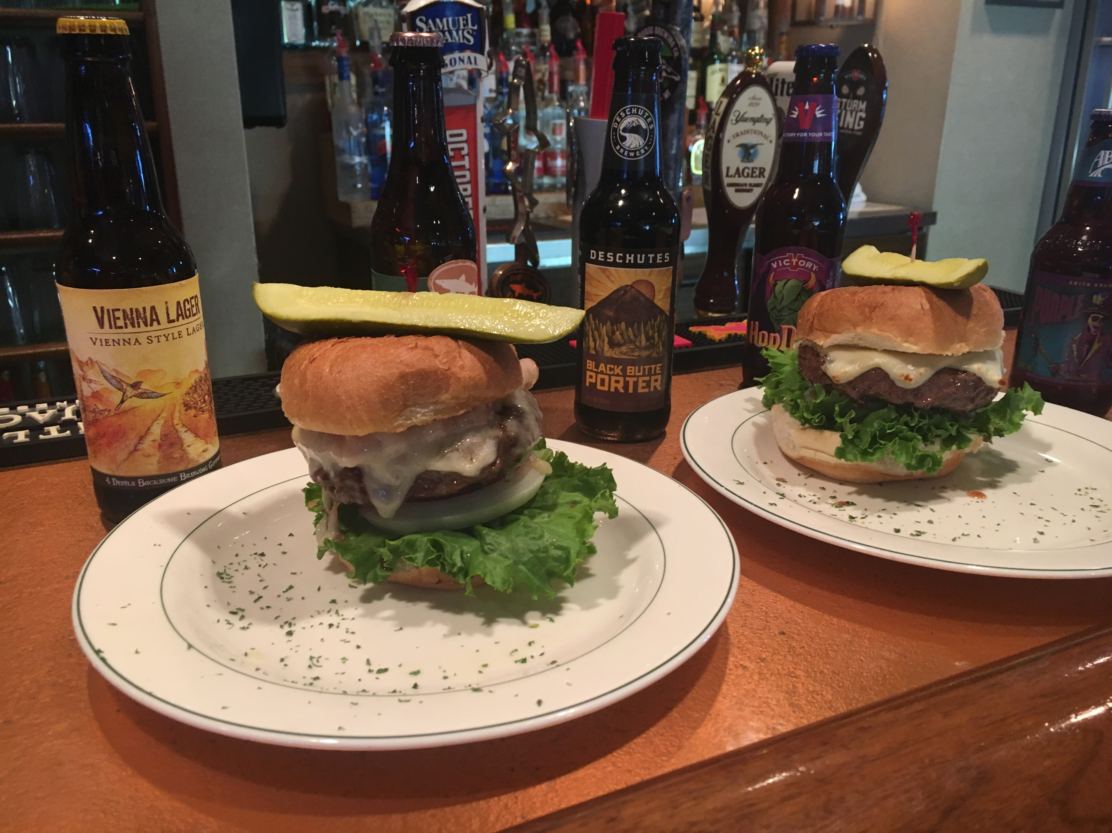

Nacho Cheese Burger $9.95
Fresh half pound certified fresh Angus burger cooked to your liking on a toasted roll smothered in nacho cheese, bacon, piled high with our crunchy French fries. With lettuce, tomato, and onion

Pulled Porker Burger $10.95
Fresh half pound certified fresh Angus burger cooked to your liking on a toasted roll topped with pulled pork, shredded cheddar jack, and fried onion rings. With lettuce, tomato, and onion

The Monster Mozzarella Burger $10.95
Fresh half pound certified fresh Angus burger cooked to your liking on a toasted roll topped with 2 mozzarella sticks, marinara, melted American. With lettuce, tomato, and onion

Crunchy Quesadilla Burger $9.95
Fresh half pound certified fresh Angus burger cooked to your liking inside a crispy quesadilla with chopped lettuce, diced tomatoes, sautéed onions, sautéed green peppers, and jalapenos. Served with a side of sour cream and salsa.

Grilled Cheese Burger $10.95
Fresh half pound certified fresh Angus burger cooked to your liking between two grilled cheese sandwiches and loaded with four pieces of bacon. Served with sautéed onions.

Mac and Cheese Burger $11.95
Fresh half pound certified fresh Angus burger cooked to your liking on a toasted roll with house made mac-n-cheese, bacon, American Cheese. With lettuce, tomato, and onion.

Substitute Pretzel Roll, Ciabatta Roll, or Wrap for $1.00
32oz Domestic Pitcher $4.95 & Half Off Specialty Drinks!
Not Valid To-Go unless a $2 up charge is added per every item that is a special.

