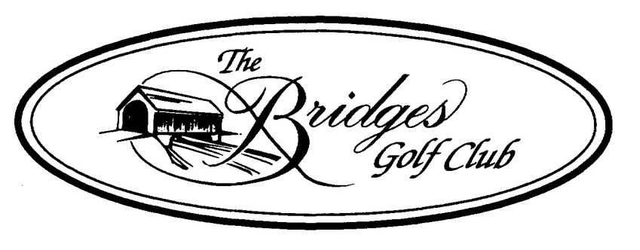
2-PERSON SCRAMBLE AGES 50+
MEN’S ~ LADIES ~ COUPLES DIVISIONS
THURSDAY MAY 31ST 2018 ~ 10:00AM SHOTGUN START
ENTRY: $110.00/TEAM INCLUDES:
Range Balls, Greens & Cart Fee, Buffet & Beverages by The Green Horizon Grill, Gross & Net Winners (may win gross or net), Closest To Pin & Long Drive (Skill & Place prizes by division)
OPTIONAL SKINS GAME: $20 PER TEAM
CURRENT VERIFIABLE USGA HANDICAP REQUIRED FOR NET DIVISION
TEAM HANDICAP = 35% PLAYER A, 15% PLAYER B
REFUND/ENTRIES 5/29/18
ENTRY FORM MEN’S ~ LADIES ~ COUPLES (CIRCLE ONE)
NAME______________________________ NAME________________________________
ADDRESS___________________________ ADDRESS_____________________________
ZIP_______ EMAIL: _________________ ZIP_______ EMAIL: ____________________
AGE____INDEX____CLUB____________ AGE____INDEX____CLUB_______________
PHONE___________________________ PHONE________________________________

THE BRIDGES GOLF CLUB ~ 6729 YORK ROAD ~ ABBOTTSTOWN, PA 17301 ~ 717 624-9551

